Predictive Analysis to avoid parking tickets in NYC

#### Akhil Padgilwar (A20427219)

#### Ganga Gudi (A20428842)

#### Ridhima Bhalerao (A20422550)

#### Sagar Ippili (A20417999)

**Introduction** **4**

**Literature Review** **4**

**Data Extraction & Processing** **7**

Selecting columns and calculating count: 8

Indexing the ‘Street Name’ column as a new ‘Street Code’ column: 9

**Comparisons for data analysis** **11**

**Analyzing the data** **14**

**Building the Recommender System** **17**

**Data Visualization** **19**

How the number of tickets given changes with each month? 19

Parking tickets are given for each violation code and violation codes: 19

Vehicle Year and Ticket count: 20

**Conclusion And Future Scope** **20**

**References** **21**

**Project Code** **23**

Appendix A: Preparing Dataset: 23

Appendix B: Importing Data to HDFS: 23

Appendix C: Analytical Queries for Database Comparison

(Hive, Pig, Spark respectively) 24

Appendix D: Building the Recommender System 25

Appendix E: Data Visualization 27

#### 

# **Introduction**

Getting a parking ticket in New York City is a very common situation and easily makes the driver spend more than $100. Parking tickets are a bit difficult to avoid in some circumstances and hence there needs to be a way to avoid them. It is necessary that people driving cars must be aware of certain tricks and tips in order to avoid tickets. Some of the tips are making use of the public transportation systems or using the cabs for commuting to work, using public garages or basically reading the signs if they want to do a street parking. Although these are useful solutions, still some people cannot avoid using their cars or misread the signs somehow. What about such scenarios?

Taking motivation from some of the applications such as ‘Ticket Wiper’ developed for this purpose, our project focuses on building a recommender system that would assist drivers in avoiding parking tickets after considering various factors explained in detail later in this document. Along with that have generated different analytical queries on the provide insights about the data. According to the surveys, parking tickets add up to 55% of the fines incurred from violations in NYC, so one can imagine how huge the data would be. Thus, we decided to compare various databases for accommodating and processing the data in the best possible way.

# **Literature Review**

Previous studies have analyzed different solution approaches to reduce the search time for parking space and ways to avoid tickets. Below are some of the work from the past literature:

[2] **Coric, Vladimir, and Marco Gruteser. "Crowdsensing maps of on-street parking spaces." 2013 IEEE International Conference on Distributed Computing in Sensor Systems. IEEE, 2013**

The author discusses about the various methodologies being used for discovering free on-street parking spaces. In this paper, they address the issue of mapping out street parking spots utilizing vehicle's preinstalled parking sensors. Additionally, they concentrated on recognizing the unlawful parking spots, for example, spots close to fire hydrants, bus stops, disabled parking. This is accomplished by crowd sensing, a methodology that gathers enormous measure of detecting information from crowds. To show how on-street parking spots can be mapped utilizing parking sensors, they utilized street side parking information acquired from Highland Park, NJ and downtown Brooklyn, NY regions. The information from these two spots is gathered utilizing PARKNET, a framework which gathers on-street parking accessibility data. The framework comprises of an ultrasonic sensor, which measures distance from the vehicle to the closest hindrance, and the GPS collector which reports the area of the sensor measurement. The job of GPS beneficiary is to give timestamps and area stamps. To induce from this information whether a street side spot is a lawful parking spot, the calculation misuses the accompanying key thought: spaces that almost never have parked cars are presumably not legitimate parking spaces. For example, fire hydrants, private carports, side streets, or transport zones. Then again, spaces which are frequently occupied almost every time are probably going to be substantial parking spots.

[3] **Kirschner, Franziska, and Martin Lanzendorf. "Parking management for promoting sustainable transport in urban neighbourhoods. A review of existing policies and challenges from a German perspective." Transport Reviews (2019): 1-22.**

The point of this paper is right off the bat to survey how the parking policy of an urban neighborhood can be organized to add to increasingly maintainable portability and to build liveability in the area. The subsequent point is to apply the arrangements audited to a model neighborhood. For this reason, they deliberately audited academic literature and distinguished five sorts of important parking strategies: (I) most extreme parking prerequisites, (ii) physical separation of home and parking spot, (iii) private parking licenses and the confinement of accessible parking spot, (iv) performance-based pricing and (v) parking as a demand management strategy. Results have demonstrated that for the execution of such parking strategies in a model neighborhood, the municipality needs to build up a versatility vision for its city. It needs to comprehend parking as an instrument for transportation demand management to expand the acknowledgment of parking policy concepts and to keep away from overflow issues. We discovered this paper is all around organized and very much clarified.

[4] **Teng, Hualiang, Yi Qi, and Ping Yi. "Parking search time and information identification for off-street spaces in New York City." Transportation research record 1800.1 (2002): 44-52**

In this paper, the authors proposed a wise system that diminishes the parking search time by investigating the vacant parking spaces and prescribing the best spot to the driver in advance. They study the connection between the parking search time and parking system to comprehend the basic fields that are required to grow such a system. They accept that this examination reinforces the requirement for such a system. The outcomes from the study are quantized and utilized in building up the system. Their examination has demonstrated that profoundly instructed guys during their work trips do a large portion of the off-street parking in New York City. The investigation uncovers that the vast majority of the workers take around one-minute hunt time as office goers have a fixed spot at the top of the priority list to leave their vehicles. They have demonstrated the pursuit time utilizing an honor model worked around a dormant relapse model that records for all autonomous and ward highlights of the commuters on the inquiry time. This paper helped us in understanding the age gathering of the vast majority of the off-street parking drivers and the top reasons, the time they take to discover a spot and the trouble level. We utilize this data in breaking down the parking tickets information and see how likely these commuters are fined for unlawful parking.

[5] **Neha Arora , James Cook , Ravi Kumar , Ivan Kuznetsov , Yechen Li , Huai-Jen Liang , Andrew Miller , Andrew Tomkins , Iveel Tsogsuren , Yi Wang, “Hard to Park?: Estimating Parking Difficulty at Scale,'' 25th ACM SIGKDD International Conference on Knowledge Discovery & Data Mining, (2019):**

This paper suggests the difficulties related to finding a parking spot at a particular time and place. According to the authors, Americans spend 17 hours in finding the right parking spot spending big amounts for the wasted resources. The data is basically aggregated user's location data through anonymous surveys which help in predicting parking spaces to users in that vicinity. This paper lays down various strategies which help in tackling the issue such as (i)Use of parking sensors (ii)Parking occupancy modelling and (iii)Route planning. These options help the car drivers find parking spots with a better efficiency and help reduce the number of tickets by parking in the appropriate space. The ML models built for implementing various strategies and their results give us a motive to perform analysis of such dataset to avoid parking tickets.

[6] **Meng Li, Chen Deng, Weimin Zhu. “The Research of Intelligent Parking System based on Internet of Things Technology” International Journal of Computer Applications (0975 – 8887) Volume 124 – No.6, August 2015**

While we are looking for techniques to avoid incorrect parking techniques to avoid parking tickets, we also considered a papers that will help us analyze how the users can adopt certain techniques to find the right parking spaces at the required locations. In this paper, the author first sees that in all cities whether big or small, there is huge demand for private cars which inturn poses the problem of parking in these areas. The traditional places allotted for parking is unable to suffice the growing demands of new cars and its required parking spaces. While there is difficulty in the availability of parking spaces, the search for it is also causing issues such as traffic congestion and heavy fuel utilization. To save this, users are parking at incorrect spaces that are causing them the parking tickets. To avoid this, the author of this paper proposes efficient smart car system, data acquisition system, data transmission system and dynamic guidance systems to help the user to find vacant parking spots real time. To achieve this technique, the author utilizes GPS dynamic map navigation and RFID tag localization, intelligent vehicle guidance system etc., to help users find the right parking spot sooner and easier.

# **Data Extraction & Processing**

1. Data Collection

We have downloaded the NYC Parking Violations data available from the [website](https://data.cityofnewyork.us/City-Government/Parking-Violations-Issued-Fiscal-Year-2020/pvqr-7yc4) for years 2014 to 2020. For the purpose of our analysis, we have chosen the files for years 2016 to 2019 containing data for all the months which have 43 data columns. Some of them are Summons_number, PlateId, Registration State, Plate_Type, Issue_Date, Violation_Code, Street_Name, etc.

1. Data Pre-processing
2. General data pre-processing:

* The data is present in three files separated by years 2016, 2017 and 2018 each having approximately 33.5M rows.
* But, since the analysis can not be performed on the individual files, it was necessary to merge all the files and getting data of all the three years together.
* To avoid the imbalance among the data, it was necessary to perform downsampling on the data.
* We thus downsampled the rows to 10.9M in total after combining all the files together.
* After using Python script processed on Spark we could achieve the sampling as well as merging (Appendix A), the data looks as follows:

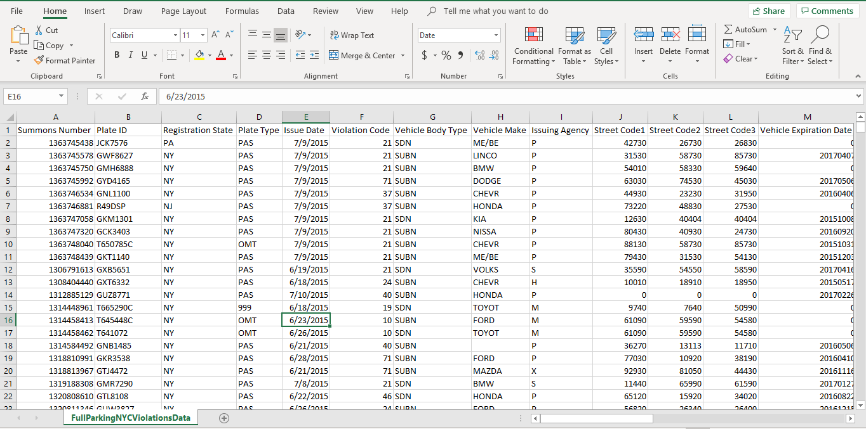

Figure 1: Preview of data

1. Recommender system-specific pre-processing:
2. **Data Import and merge:**

* We imported each year’s data (approx. 30 million records) into PySpark data frames and merged three years of data, i.e 2016, 2017 and 2018.
* For building the recommender system, we need to split the data into training data and testing data sets.
* For the training dataset, we used the merged data of the years 2016, 2017 and 2018. and 2019’s data (approx. 10 million records) alone for testing using pandas and spark.
* The data is as follows:

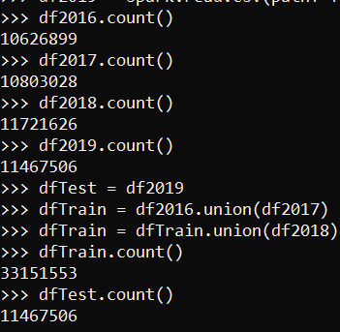

Figure 2: Number of records in each data set, merged train data and test data

##### **Selecting columns and calculating count:**

* For the Collaborative Filtering approach, we need the columns to be in the user-item-rating format, and here we’ll be using ‘Street Name’, ‘Violation Code’ and ‘Violations Count grouped by Street Name and Violation Code’ in place. We need only ‘Street Name’ and ‘Violation Code’ columns from the merged data.
* The training and testing of data frames can be seen below:

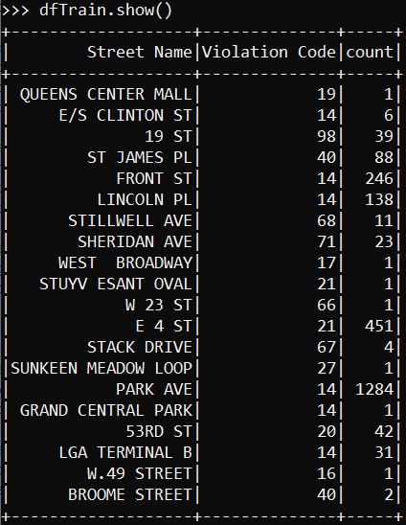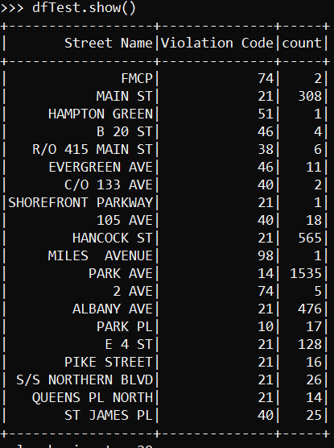

Figure 3: Training & Testing Data Frames

##### **Indexing the ‘Street Name’ column as a new ‘Street Code’ column:**

* For calculating the similarity between the count of violations, we need the ‘Street Name’ to be numerical. Hence, we’ll be using PySpark’s MLlib library to convert the string to index, which creates a new unique index for each street name, which will later be used for mapping the predictions for a particular street.

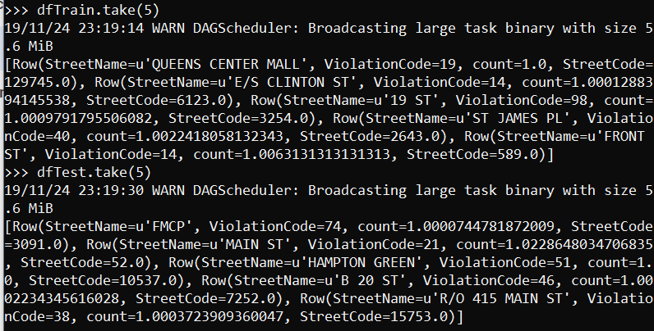

Figure 4: Indexed Train and Test data frames to ‘Street Code’

1. **Scaling/Normalizing the ‘count’ column:**

* The count column contains values in a continuous fashion and is not bound to a range, which makes the training and predictions irrelevant. As a result, we will scale the count column on a range from 1 to 5, and normalize. We will now consider the scaled count column in place of rating for collaborative filtering’s matrix.

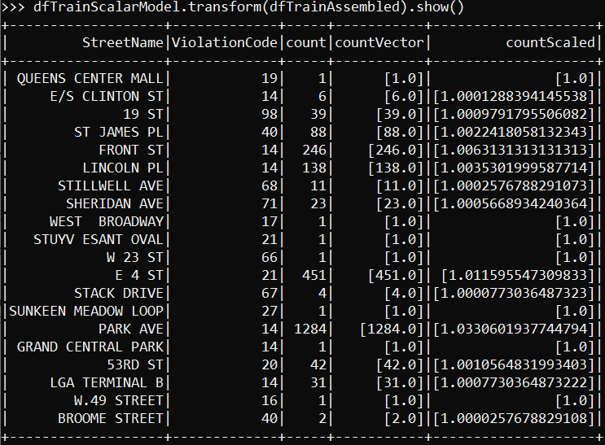

Figure 5: Scaled Train data frame

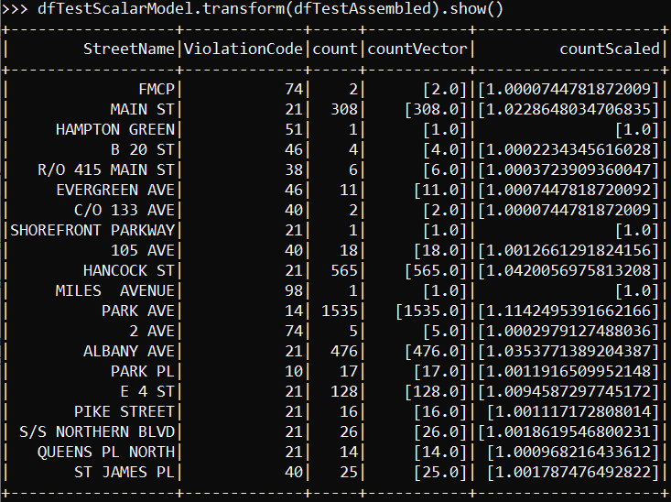

Figure 6: Scaled Test data frame

C**.** Visualization-specific pre-processing:

* The last three columns in this dataset i.e. ’No Standing or Stopping Violation', 'Hydrant Violation', and ‘Double Parking Violation’ do not have any data present in it, so we can ignore those columns while carrying out any visualization operation in the data frame.
* Also if the entry does not have a Plate ID it is very hard to locate those cars, hence it is better to drop these columns.
* The column ‘Registration State’ contained dirty value ‘99’, which was removed using Python script.

D. Data Import in HDFS:

For performing the further analysis of the data using Pig, Hive, and Spark, it is necessary to move the data into Hadoop Distributed File System from the local system. The following images depict the total time required to import the data into HDFS:

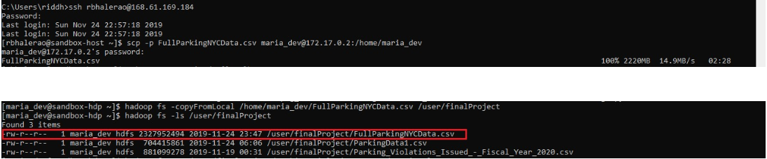

Figure 7: Importing data into HDFS

# **Comparisons for data analysis**

For the purpose of selecting the right resources to perform analysis of the data, we took into consideration the performance of three big data technologies: Apache Hive, Apache Pig and Apache Spark. We evaluated the performance based on data upload speed and query response time.

1. Apache Hive:

Apache Hive is an open-source data warehouse technology utilized to handle big data and gives an ease of access since it provides SQL structure for data projection and processing. We created a hive table schema to create a way to store the data and loaded the data using the ‘load infile’ query directly from the .CSV file stored in HDFS. Once the data was loaded into the table, we performed analysis queries on it using the Hive Query Language to generate the required results. These results were then useful for comparing with the other databases as shown in the below table. The code can be found in Appendix C for the reference.

1. Apache Pig:

Apache Pig is basically a scripting language used to analyze large datasets and perform complex transformations on the data. Unlike Hive, Pig is a semi-structured Hadoop component. Once the data was loaded on HDFS, we used an interactive mode, Grunt shell, to run Pig Latin statements to get the required output. Different Load and STORE commands were used to load the data and define their data types. Their schema had also been defined. The extracted data was filtered, grouped, ordered and looped to transform it and get the expected results. The code can be found in Appendix C for the reference.

1. Apache Spark**:**

Apache Spark is a distributed engine for processing data and performing batch jobs on large datasets along with streaming data. Apache spark is a tool that allows us to ingest data, perform transformations on data and storm them in hive table and again do analysis on them. Apache spark will do the batch processing and increase the overall performance. It has the capability of doing in-memory computation.The code can be found in Appendix C for the reference.

* The parameters that we have considered for evaluating the best strategy for our dataset are:

1. **Data import time in a table/RDD**
2. **Query Response Time in seconds**

* We performed five analytical queries on each of the databases and the statistics are as follows:

|  |  |
| --- | --- |
| **Query Number** | **Query Type** |
| Query 1 | Analysis to find the total parking ticket violations for NY state vs Other States |
| Query 2 | Analysis to find the total parking ticket violations according to the brand of the car |
| Query 3 | Analysis to find the number of parking ticket violations by registration state |
| Query 4 | Analysis to find the number of parking ticket violations by plate ID and Number of Parking Violation count |
| Query 5 | Analysis to find the number of parking ticket violations by Street and Number of Parking Violation count |

* The individual query response time and import time are as follows:

|  |  |  |  |
| --- | --- | --- | --- |
|  | **Hive** | **Pig** | **Spark** |
| **Import Time for data(Table/PigStorage/RDD)** | 44.42 | 15.39 | 3.00 |
| **Query 1** | 112.19 | 720.12 | 80.03 |
| **Query 2** | 83.04 | 780.00 | 42.20 |
| **Query 3** | 79.92 | 720.00 | 33.00 |
| **Query 4** | 105.52 | 733.13 | 46.65 |
| **Query 5** | 90.08 | 660.00 | 31.92 |

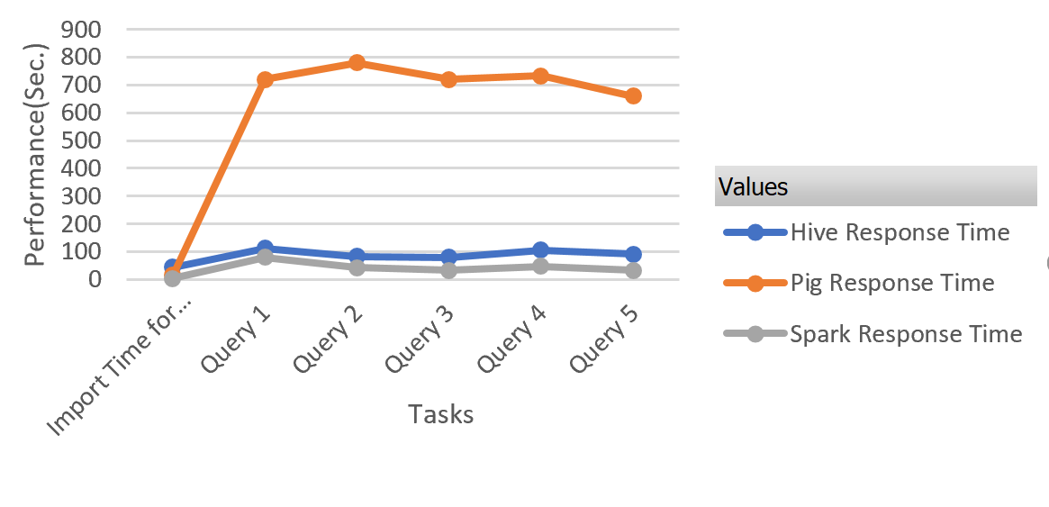

Figure 8: Statistical Comparison

* From the above statistics, it was clear that Spark stands out in terms of performance and efficiency as compared to Hive and Pig. Hence, we decided to perform the analysis of the dataset using Spark.

# **Analyzing the data**

* Since Spark stands out amongst all the three databases that we compared, we performed a few analysis queries to generate insights from the data. The analysis we performed is as follows:

1. **Analysis to find the total parking ticket violations for NY state vs Other states:**

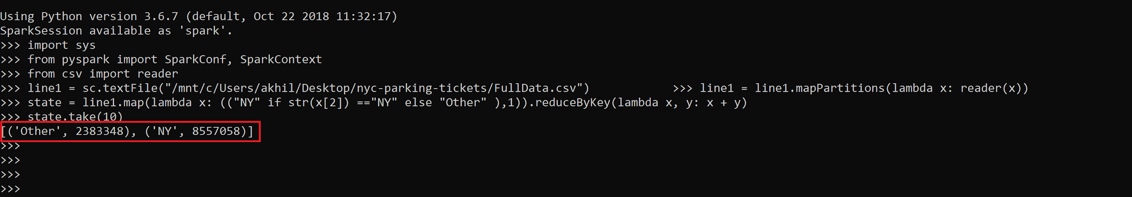

Figure 9: NY vs Other states

From this analysis, we can estimate the total tickets generated in New York comparable with other states combined and it becomes clear that the number of violations in NY are very high.

1. **Analysis to find the total parking ticket violations according to the brand of the car:**

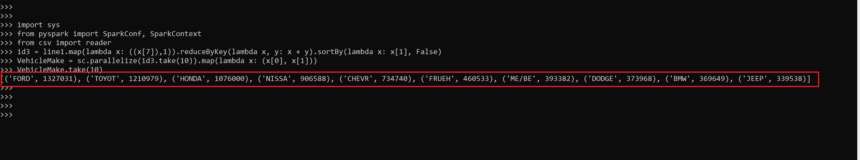

Figure 10: Analysis according to car make

From this analysis, we can estimate that people owning Ford or Toyota or Honda cars in New York are in the topmost layer to get tickets for parking violations followed by luxury brands like BMW. The output can be hence, visualized as follows:

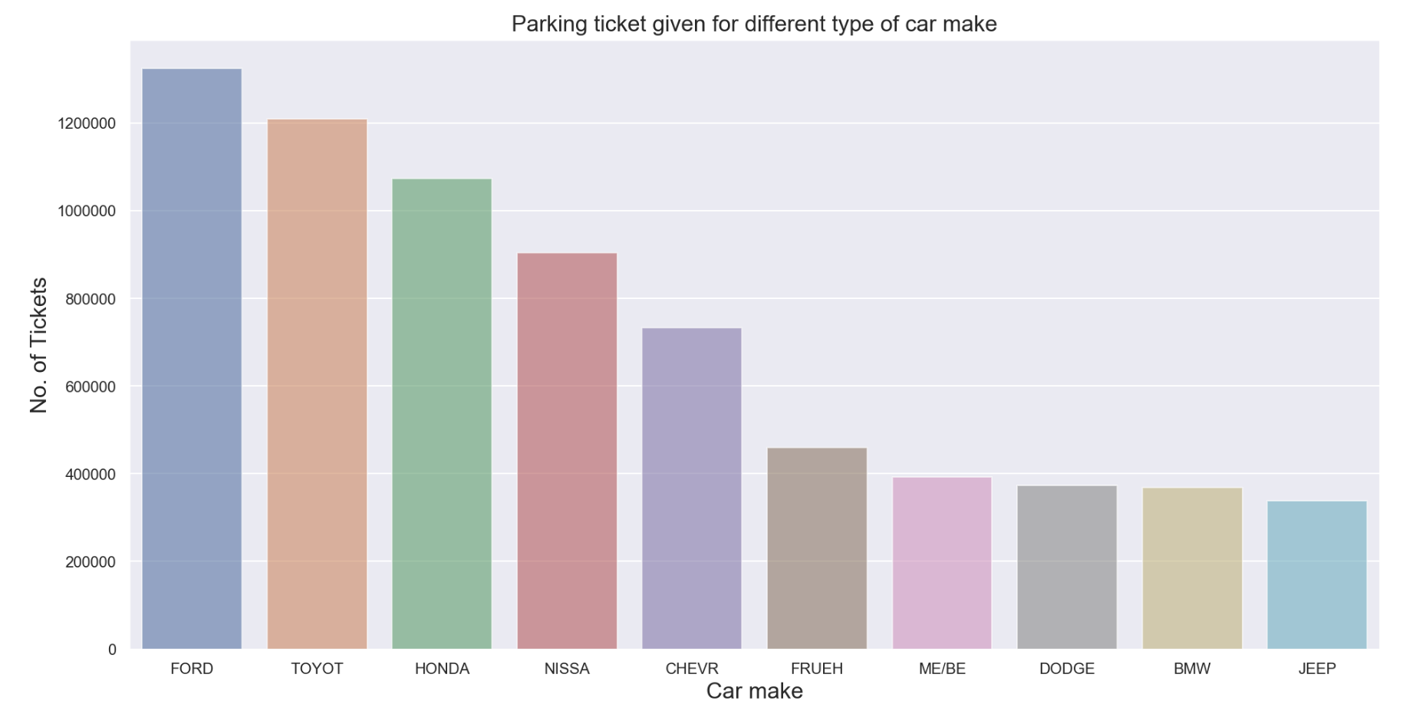

Figure 11: Visualization of the query

1. **Analysis to find the number of** **parking ticket violations** **by registration state:**

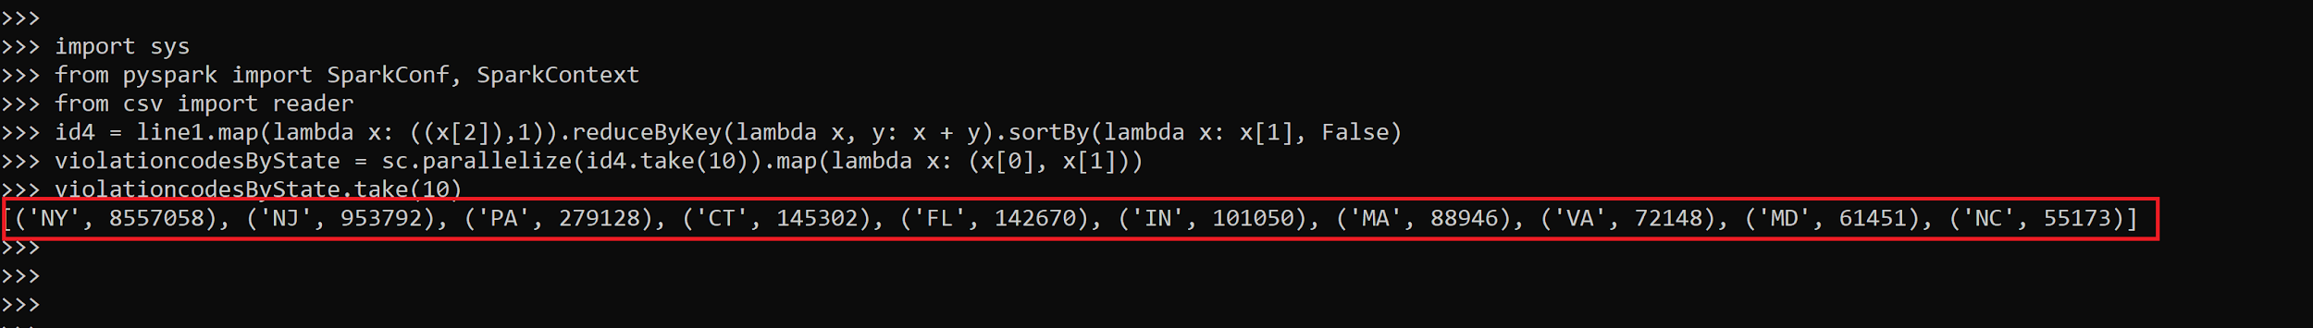

Figure 12: Tickets by state

From this analysis, we can understand individual state parking ticket count and clearly violations in New York are maximum compared to any other state, and the results are ordered from the highest count to lowest. The results can be visualized as follows:

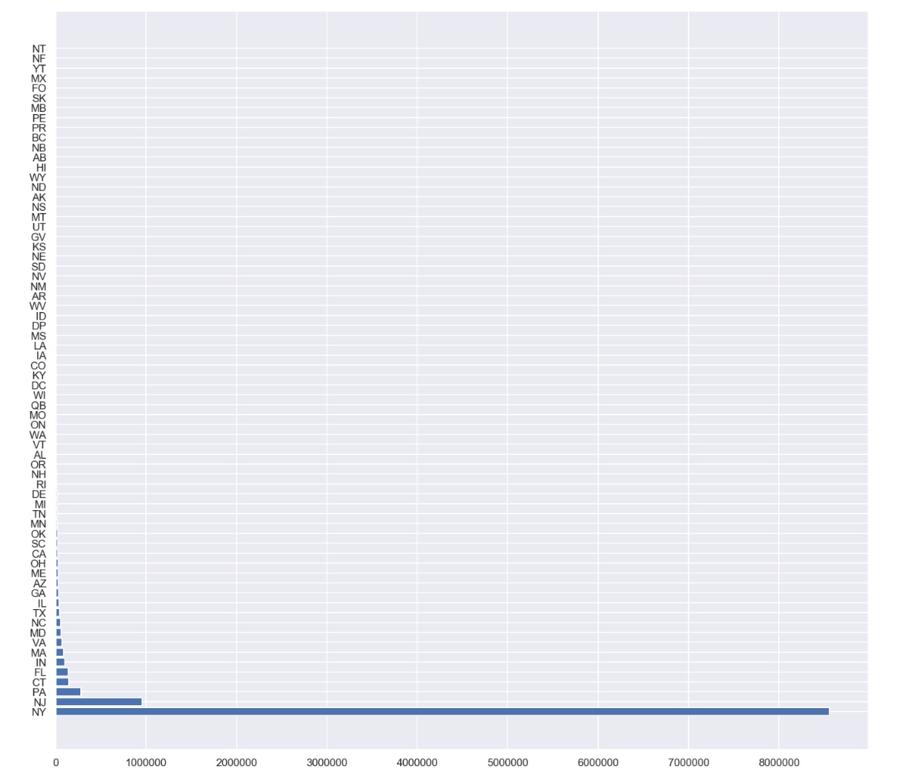

Figure 13: Registration States Vs Total Tickets

1. **Analysis to find the number of** **parking ticket violations** **by** **plate ID and Number of Parking Violation count:**

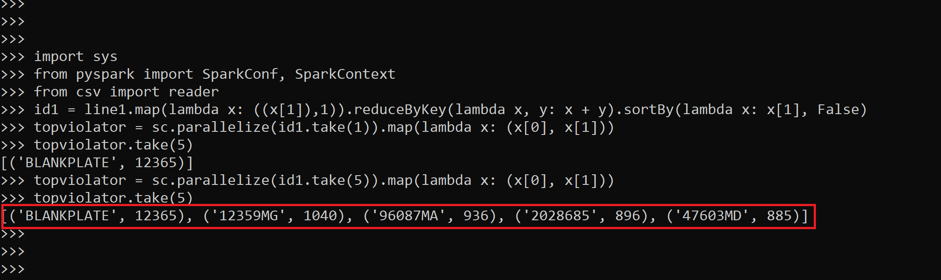

Figure 14: Violation by plateID

From this analysis, we can find plates that have been responsible for maximum parking violations. From that, it becomes clear that cars having ‘BLANKPLATE’ are the maximum violators.

1. **Analysis to find the number of** **parking ticket violations by Street and Number of Parking Violation count**

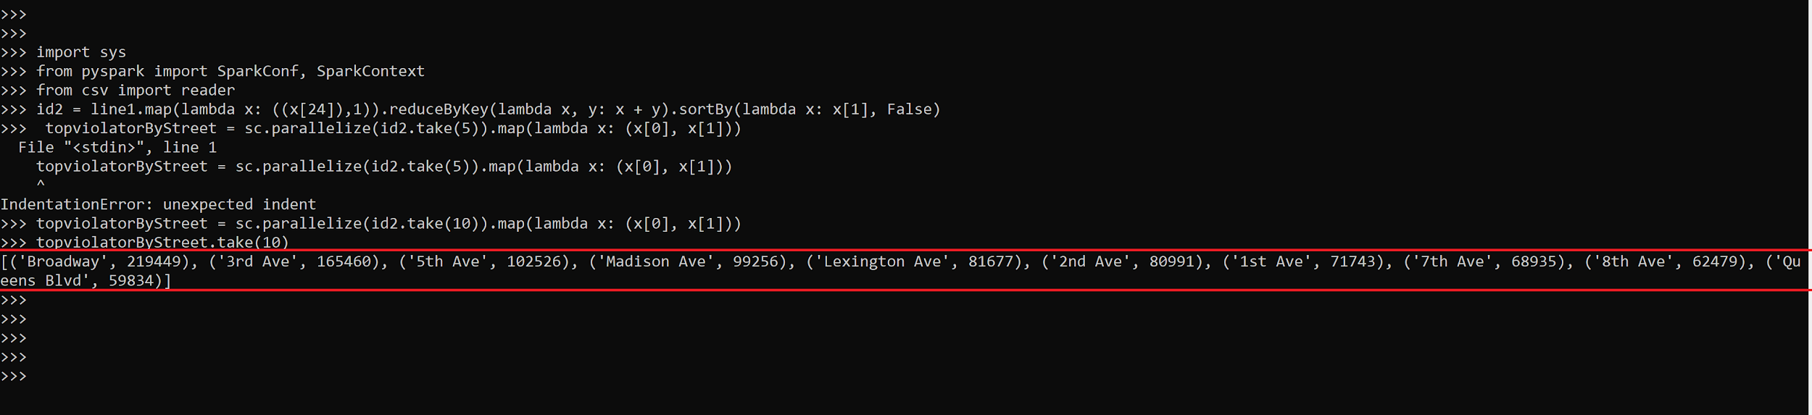

Figure 15: Violation by street

From this analysis, we can find total violations on streets that appear to collect maximum fines from the drivers. The results can be visualized as follows:

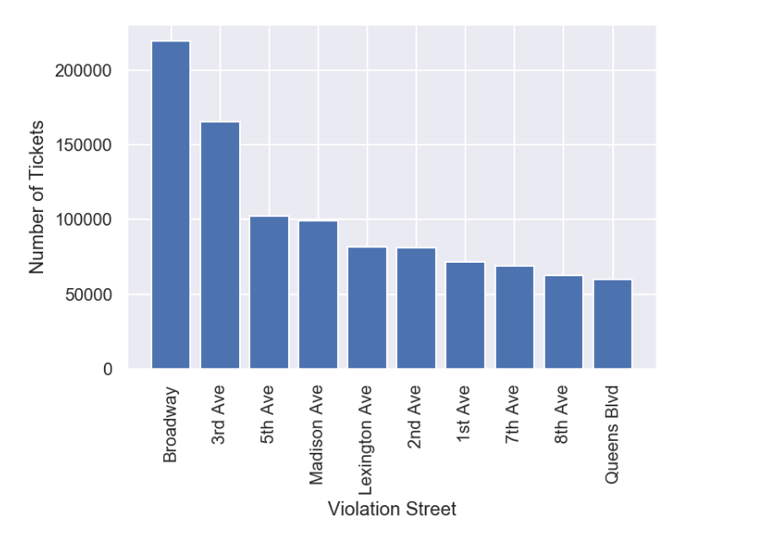

Figure 16: Visualization of the query

# **Building the Recommender System**

1. Build the recommender model using ALS library:

#### Using the ALS and ALSModel modules, from MLlib library, we will build the recommendation model using ALS on the training data, followed by predictions and evaluating them using the testing data. A model is said to be good only when the RMSE evaluating predictions are lower. We tried different parameters with the ALS and found to have the least **RMSE of 0.44057** when the **rank=200**. Below can be seen the top violation codes for 10 [random] streets:

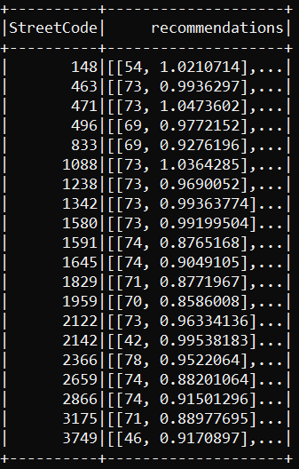

Figure 17: Possible violation codes for different streets (by ‘Street code’)

1. Making predictions for the top 10 streets with the highest number of violations:

* From our analytics, we can see that the following are the top streets where the majority of the violations occurred and are ticketed. With the recommendation system built using the ALS library, we can predict the top violations that one has been ticketed for parking their vehicle on those streets.
* **Top 10 Streets**: Broadway, 1st Ave, 2nd Ave, 3rd Ave, 5th Ave, 7th Ave, 8th Ave, Madison Ave, Lexington Ave, Queens Blvd.

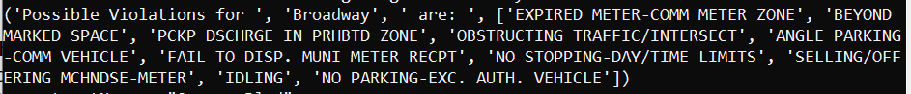

Figure 18: Sample predictions for one of the top streets, ‘Broadway’

* To summarize, we designed a recommendation system that presents the commuter with the likely reasons to get ticketed at his/her destination place.
* Collaborative filtering is one of the most popular approaches to build recommendation system and PySpark known for its greater speed due to its powerful caching and disk persistence for datasets made it incredibly faster, and easier to handle the large data sets (approx. 90 million records) with speed computation, less coding, and efficient results.
* The code can be found in Appendix D for the reference.

# **Data Visualization**

Generating visualizations makes it clear for the user to understand the analysis of the data, hence we have generated certain graphs and visualizations to make our ideas seamless for the users to follow:

## **How the number of tickets given changes with each month?**

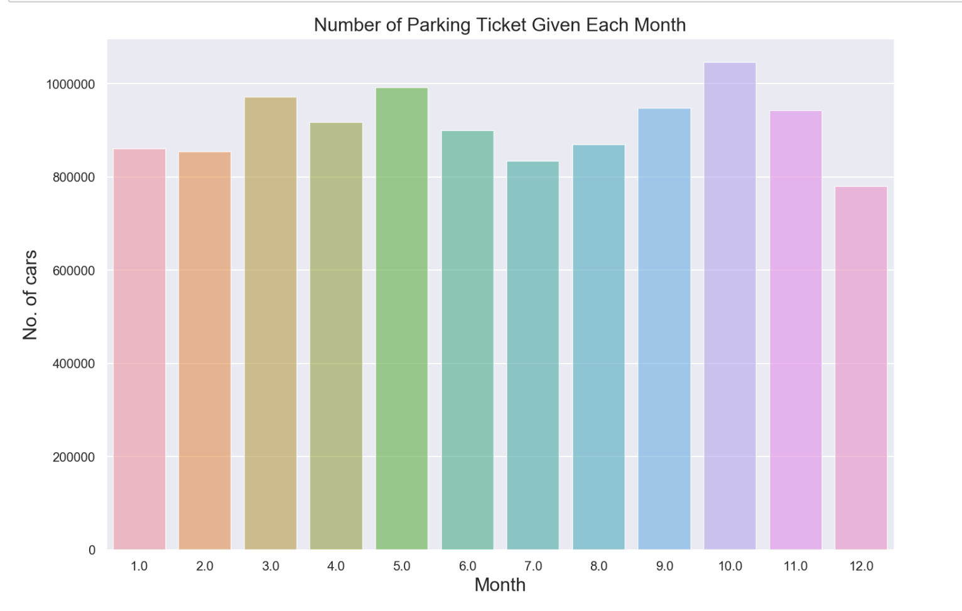

Figure 19: Tickets each month

## **Parking tickets are given for each violation code and violation codes:**

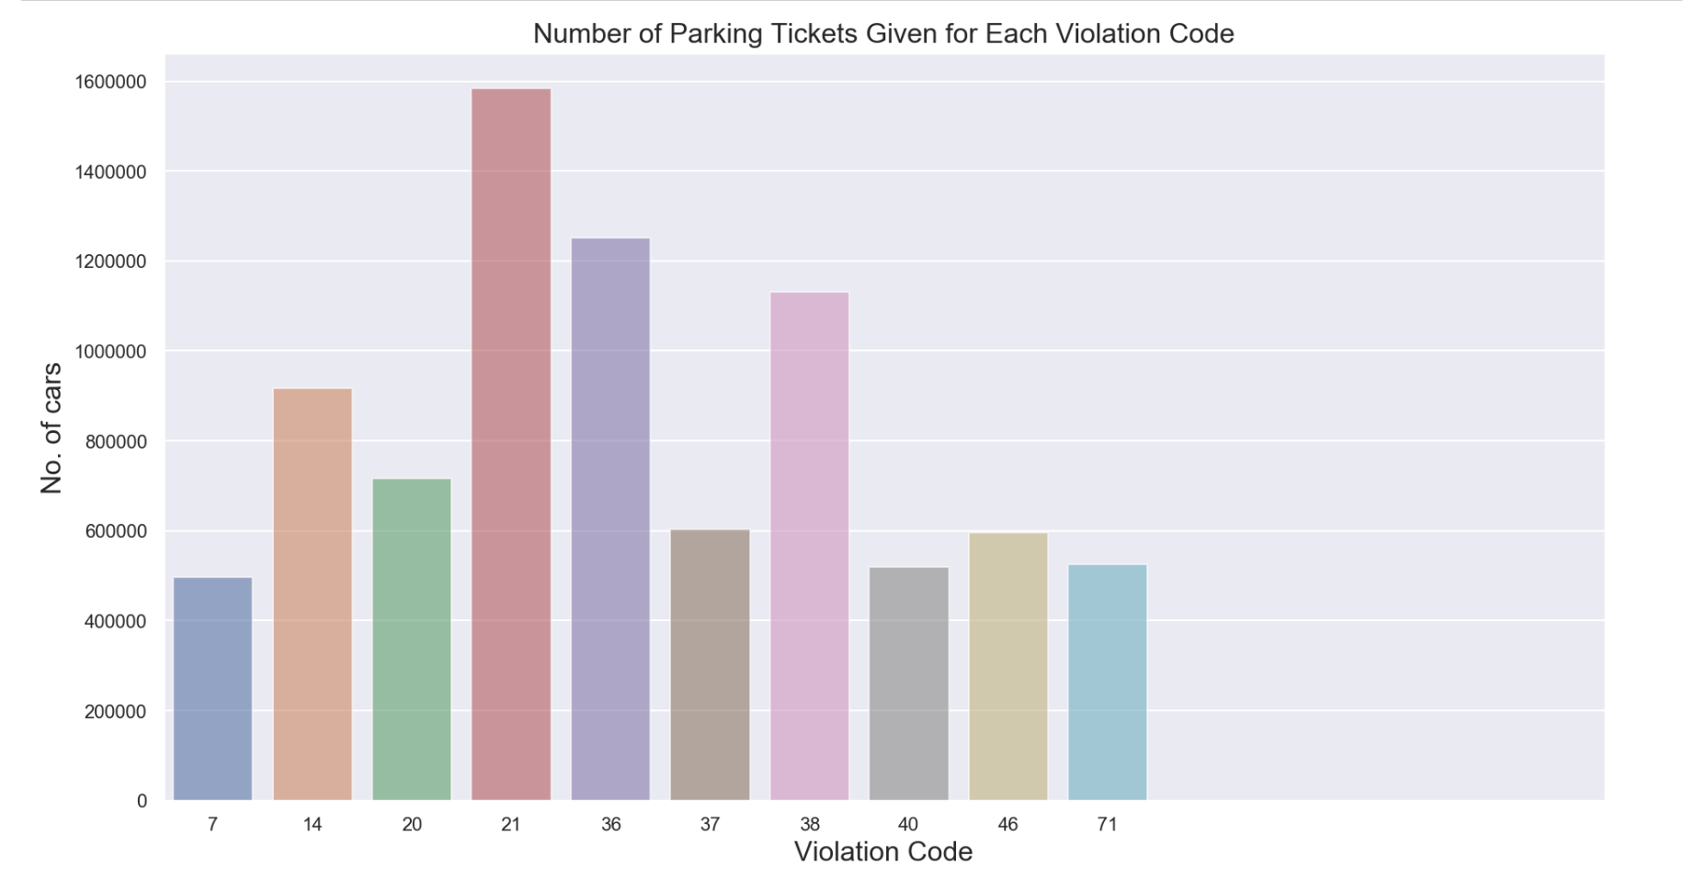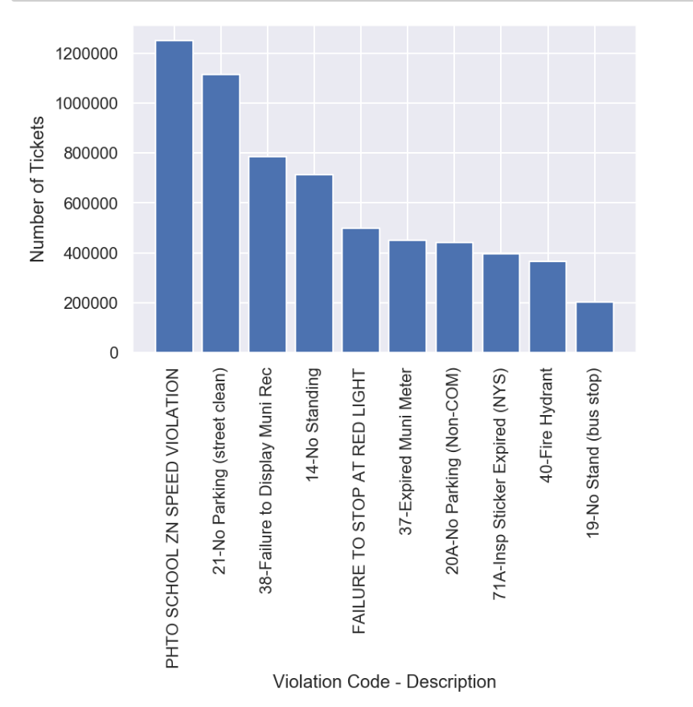

## 

Figure 20: Visualization by violation codes

## **Vehicle Year and Ticket count:**

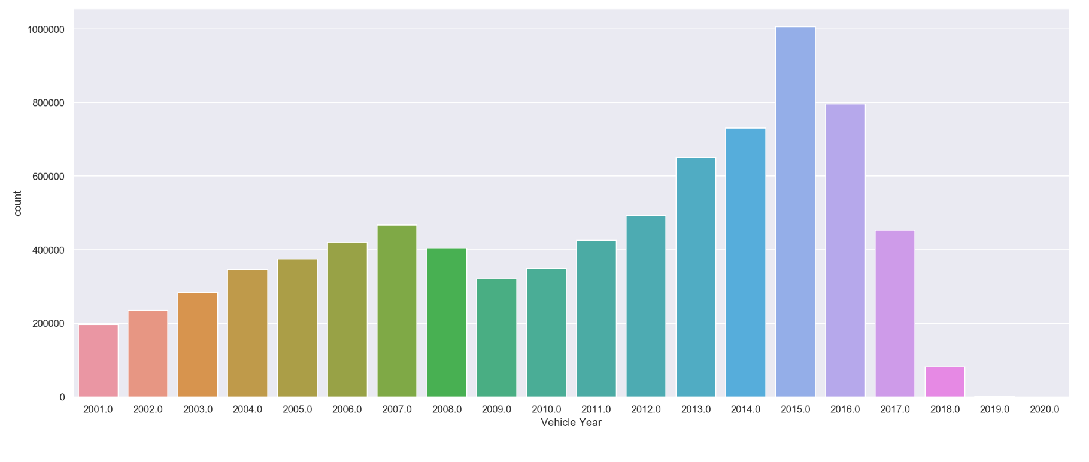

Figure 21: Ticket count by year

# **Conclusion And Future Scope**

As the saying goes, you don’t understand unless you get your hands dirty with knowledge. From this project, our main goal was to understand the Big Data technologies in depth. We made use of three technologies Apache Hive, Apache Spark and Apache Pig. By performing the analysis on the technologies, it became easier for us to measure the performance of each of these technologies based on the dataset that we chose. After getting the results, it became clear that Apache Spark stood out in terms of performance. We chose Apache Spark which helped us systematically extract information to solving one of the real-life problems considering the huge amount of data collected from many years. Using Spark, we successfully performed Data Integration and Interactive Analysis.

Once we realized the factors that might be the possible reasons for parking violations, we decided to build a recommender system to give recommendations which might help them in avoiding the tickets.The collaborative recommender system helped us predict the best reasons for anyone to get a parking ticket and how one could not commit the same mistake in the future.

As a future scope, we plan on designing an interface to communicate with the commuter. We also plan to test our recommender with different ML algorithms to generate a model with better compared accuracies.

# **References**

### **Reference Papers**

|  |  |
| --- | --- |
| [1] | Vladimir Coric and Marco Gruteser. Crowdsensing maps of on-street parking spaces. In *Proceedings of the 2013 IEEE International Conference on Distributed Computing in Sensor Systems*, DCOSS ’13, pages 115–122, Washington, DC, USA, 2013. IEEE Computer Society. |
| [2] | Franziska Kirschner and Martin Lanzendorf. Parking management for promoting sustainable transport in urban neighbourhoods. a review of existing policies and challenges from a german perspective. *Transport Reviews*, 0(0):1–22, 2019. |
| [4] | Hualiang Teng, Yi Qi, and Ping Yi. Parking search time and information identification for off-street spaces in new york city. *Transportation Research Record*, 1800:44–52, 01 2002. |
| [5] | Neha Arora , James Cook , Ravi Kumar , Ivan Kuznetsov , Yechen Li , Huai-Jen Liang , Andrew Miller , Andrew Tomkins , Iveel Tsogsuren , Yi Wang, Hard to Park?: Estimating Parking Difficulty at Scale, *Proceedings of the 25th ACM SIGKDD International Conference on Knowledge Discovery & Data Mining*, August 04-08, 2019, Anchorage, AK, USA |
| [6] | Meng Li, Chen Deng, Weimin Zhu. The Research of Intelligent Parking System based on Internet of Things Technology. International Journal of Computer Applications (0975 – 8887) Volume 124 – No.6, August 2015 |
| [7] | <https://towardsdatascience.com/how-to-build-a-simple-recommender-system-in-python-375093c3fb7d> |

**Dataset**

|  |  |
| --- | --- |
| [8] | NYC OpenData (<https://data.cityofnewyork.us/City-Government/Parking-Violations-Issued-Fiscal-Year-2020/pvqr-7yc4>) |

#### **Software**

|  |  |
| --- | --- |
| [9] | ALS recommender, Spark MLlib, Python (For Recommender System) |
| [10] | Spark, Hive, Pig (For Data Analysis) |

## 

## **Project Code**

### Appendix A: Preparing Dataset:

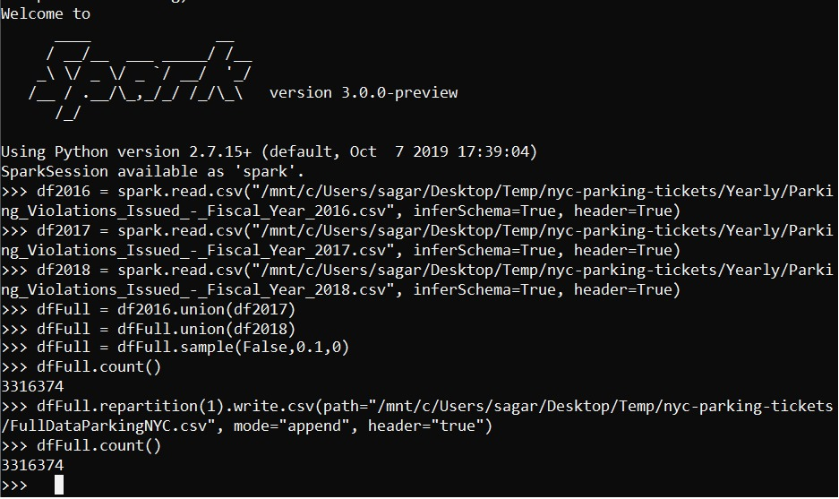

### Appendix B: Importing Data to HDFS:





### Appendix C: Analytical Queries for Database Comparison (Hive, Pig, Spark respectively)

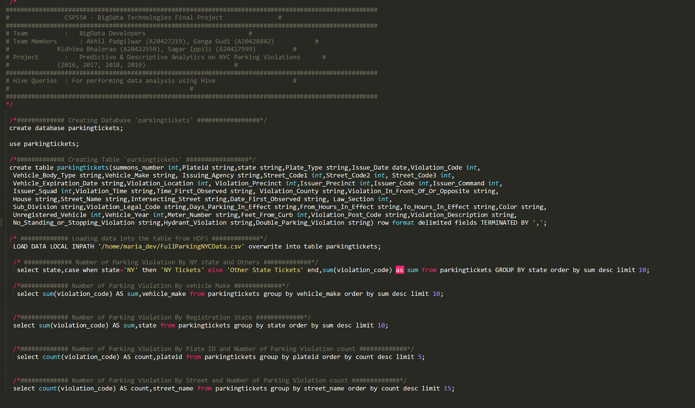

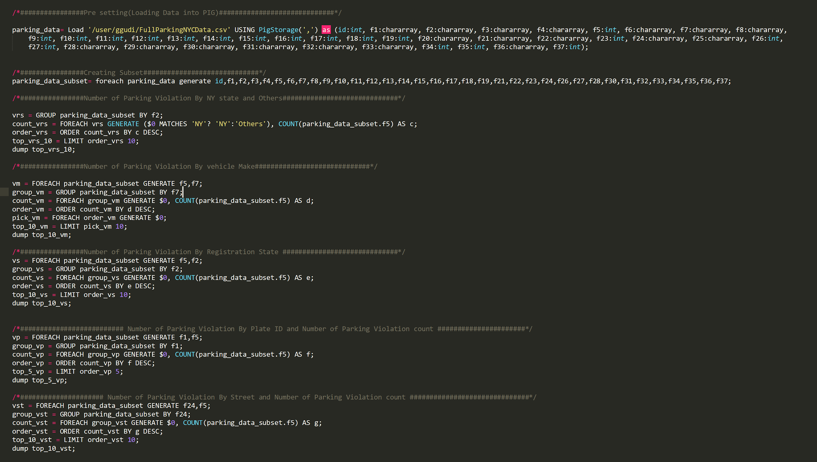

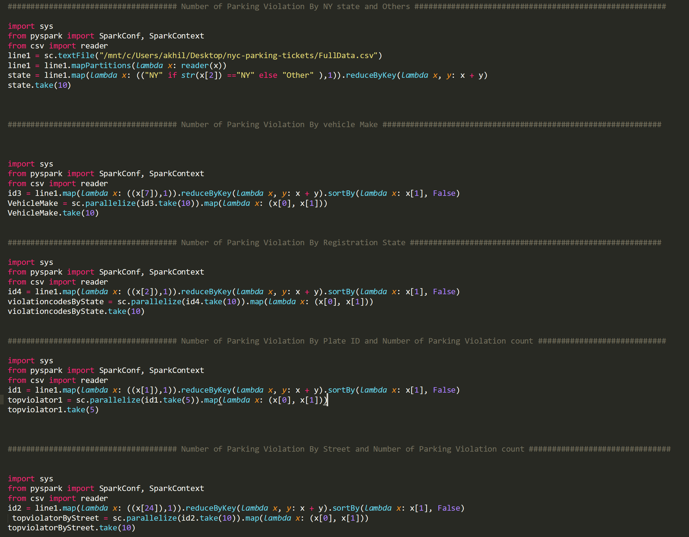

### Appendix D: Building the Recommender System

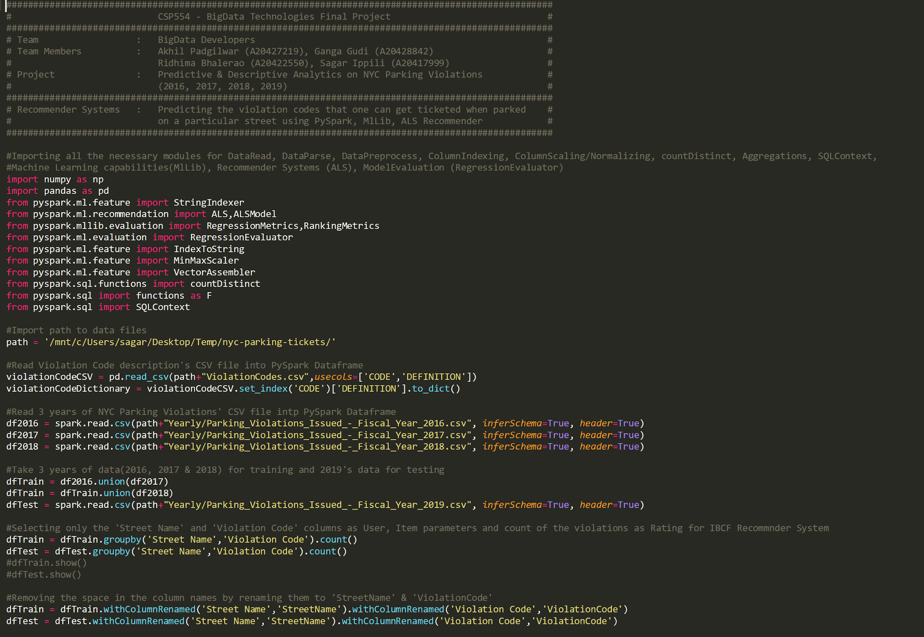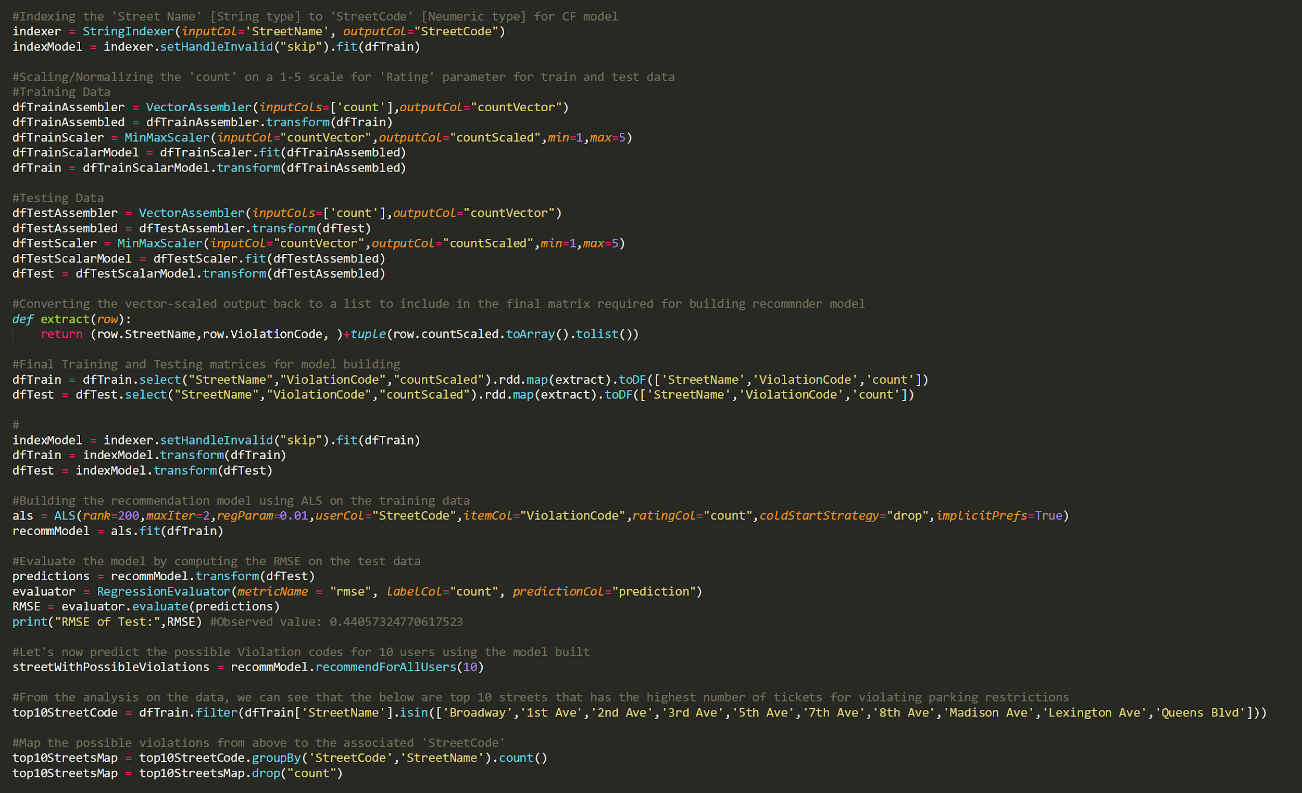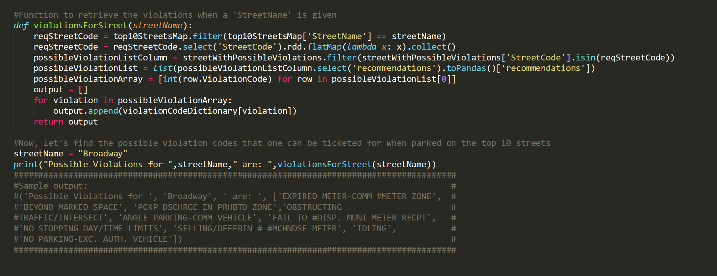

### Appendix E: Data Visualization

